TASK-1

CREATING RG,NSG,INBOUND AND OUT BOUND.

Creating Resource group with name SuryaRG1.

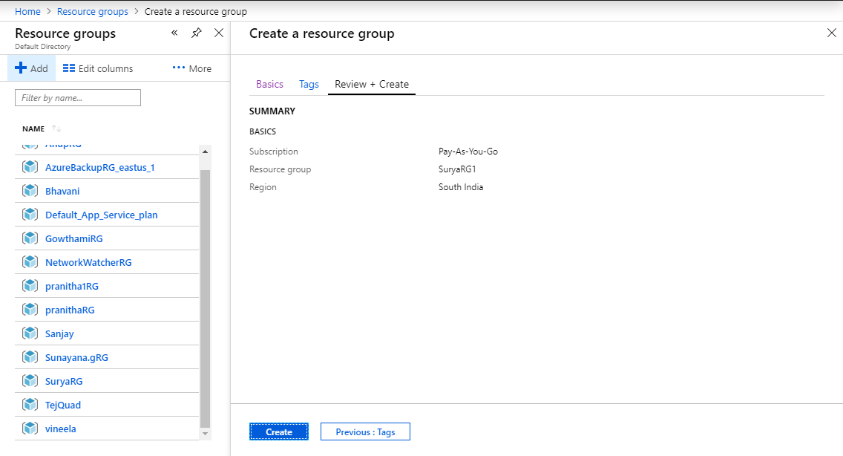

Creating front end and backend NSG rules in SuryaRG1.

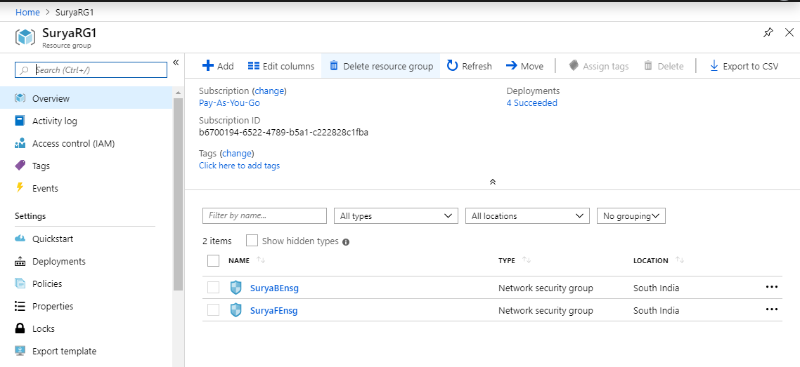

Creating front end inbound rules in NSG RDP,HTTP,MSSQL AND SSH.

Created front end inbound rule in NSG RDP .

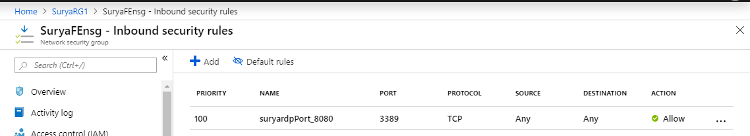

Created front end NSG inbound HTTP.

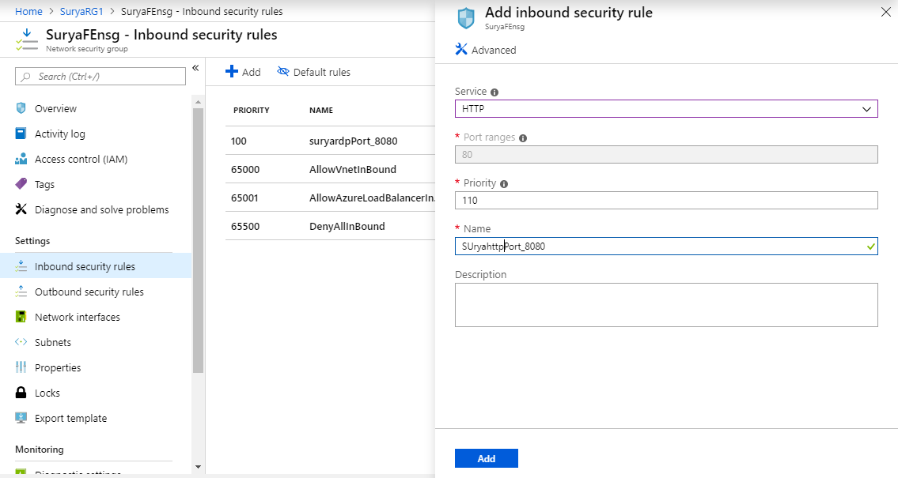

Created front end NSG inbound MSSQL.

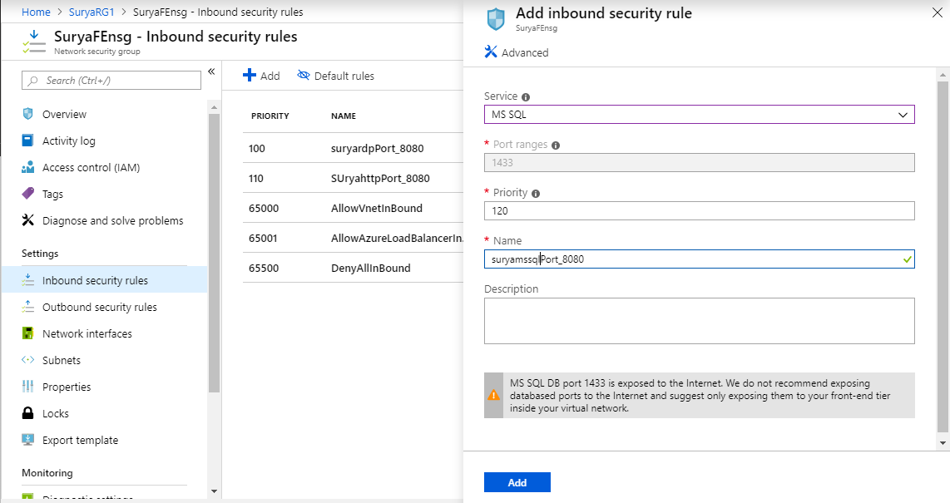

Created front end NSG inbound SSH.

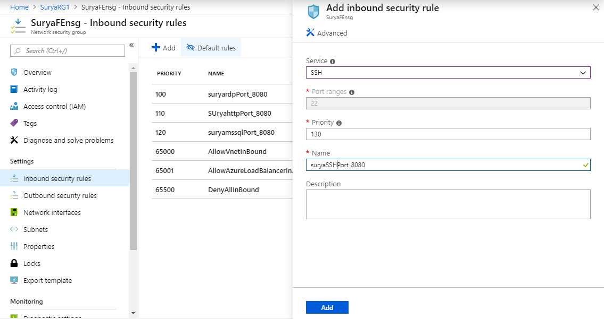

ALL FRONT END NSG INBOUND RULES.

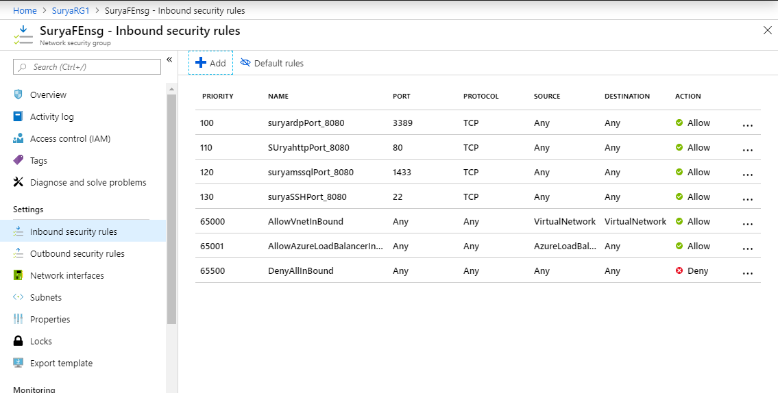

Back end NSG outbound rules MSSQL.

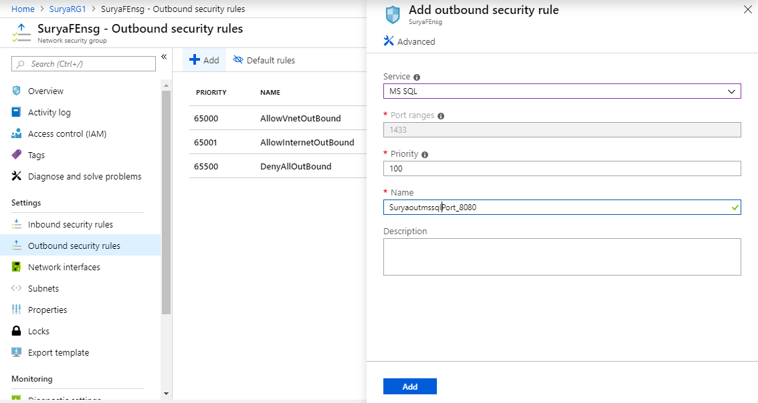

Backend NSG outbound rule in HTTP



All Backend outbound security rules in NSG.

